I wish to determine how the initial height of where a rubber ball is dropped from affects the apex of its first bounce.

In this experiment I will drop a rubber ball from various heights. After I have dropped the ball I will measure the apex of its first bounce by using a video camera with a tape measure as the background. With the video camera, I will review the footage and obtain the bounce heights measurement relative to the bottom of the ball. In this experiment, my independent variable is the height of which the rubber ball is dropped and my dependent variable is the apex of the bottom of the ball of the ball’s first bounce.

There are five variables that I see that can affect the results of this experiment. Therefore, I must control these variables to limit their influence on the data I intend to collect. To effectively control these variables, I must do the following:

* Height Dropped
  + For each trial and iteration I perform, I must drop the ball from the same height. I will do this by rolling a ball off a predetermined object of which the height will not change.
* Impact Surface
  + For each trial and iteration, I will drop the ball onto the same surface.
* Surrounding Environment (Ex: air pressure, temperature, etc.)
  + The environmental conditions will be maintained at constantly as possible throughout the course of the experiment.
* Data Recording
  + I will be performing all the data measuring to keep a constant amount of random error.
* Rubber Ball
  + I will use the same rubber ball for each trial and iteration.

The experiment will proceed as follows. I will drop a rubber ball at 6 different heights. I will drop the ball by rolling it off an object with a flat top of the desired height. After I roll the rubber ball off the flat surface, I will view the video footage the recorded the bounce of the rubber ball to measure the apex of the bottom of the ball of the first bounce of the ball.

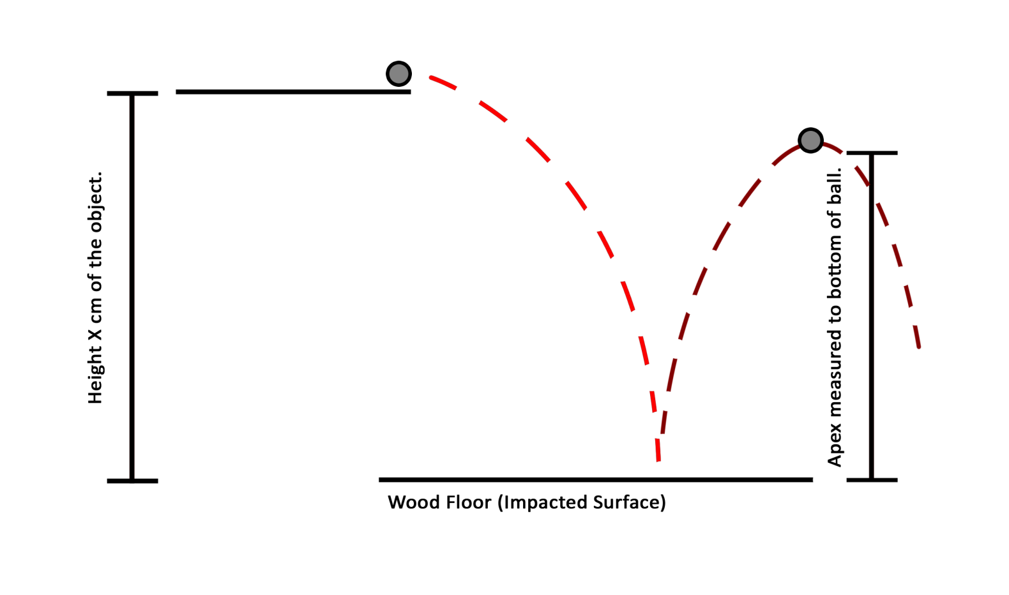

*\*Not drawn to scale.*

I will repeat this experiment for five iterations before beginning the next trial. Each successive trial will use a different object with a different height from where the rubber ball will fall from, and each trial will have five iterations. The experiment will be concluded when six trials are completed.

Height Drop vs. Bounce Height

|  |  |  |  |  |
| --- | --- | --- | --- | --- |
| **Trial** | **Initial Height** DH / cm ∆DH = ± 0.1 cm | **Average Initial Height** ∆DH = ± 0.1 cm | **Bounce Height** BH / cm ∆BH = ± 0.2 cm | **Average Bounce Height** ∆BH = ± 0.4 cm |
| **1** | 18.8 | 18.8 | 17.5 | 17.4 |
| 18.8 | 17.5 |
| 18.8 | 17.0 |
| 18.8 | 17.3 |
| 18.8 | 17.6 |
| **2** | 22.6 | 22.6 | 21.6 | 22.1 |
| 22.6 | 22.3 |
| 22.6 | 22.2 |
| 22.6 | 22.0 |
| 22.6 | 22.2 |
| **3** | 29.0 | 29.0 | 27.1 | 26.9 |
| 29.0 | 27.2 |
| 29.0 | 27.0 |
| 29.0 | 26.9 |
| 29.0 | 26.4 |
| **4** | 52.3 | 52.3 | 42.5 | 42.8 |
| 52.3 | 42.6 |
| 52.3 | 43.3 |
| 52.3 | 42.7 |
| 52.3 | 42.7 |
| **5** | 61.5 | 61.5 | 54.9 | 54.9 |
| 61.5 | 54.7 |
| 61.5 | 55.2 |
| 61.5 | 54.8 |
| 61.5 | 54.9 |
| **6** | 71.0 | 71.0 | 57.4 | 57.8 |
| 71.0 | 57.6 |
| 71.0 | 58.1 |
| 71.0 | 57.8 |
| 71.0 | 58.2 |

The uncertainty in the ‘Bounce Height’ column is doubled because when I was determining its value by viewing the video footage, I was not able to see which millimeter mark it met. Doubling the uncertainty worked well to have the bounce height within the range of uncertainty.

*Notice: Both x and y-axis error bars a present.*

The best fit line of this graph has a gradient of 0.37833. This means that the apex of the first bounce increases by this amount for every centimeter of additional initial height. Using a linear fit line, I have an R2 value equal to 0.9888, which means that I have a correlation coefficient of 97.8%. Because of this correlation coefficient, we can determine that the gradient accurately demonstrates the relation between the drop height and bounce height apex of a rubber ball. This is statically significant and gives hope to my date. However, I am troubled by the fact that the y-intercept is three centimeters above zero. With my data, that would mean that if I dropped my rubber ball from 0 cm, it would still bounce 3 cm on its first bounce. Either there is an unanticipated systematic error present or the true relationship is not linear. To further ascertain the relationship, I created a logarithmic graph.

This logarithmic graph indicates a 98.6% correlation between the logarithms and creates an even more accurate linear best fit line. The gradient of this logarithmic graph’s best fine line is equal to the power to which the drop height is raised to determine the bounce height. The power is calculated to be 0.892. As well, this graph has eliminated my fear that was presented from the last graph. That is the y-intercept being too high. On this graph, the y-intercept is 0.1198; this is a much better y-intercept and makes sense because there are uncertainties involved in the experiment. This number is within the bounds of experimental error. The correlation coefficient is statically high, therefore I hypothesize that there exist a linear relation between the height of which something is dropped at and its apex on the first bounce.

The best fit gradient is calculated to be 0.892. Calculating maximum and minimum gradients:

Maximum gradient = (58.2 - 17.0) / (71.0 – 18.8) = 0.789

Minimum gradient = (57.4 – 17.8) / (71.0 – 18.8) = 0.759

The gradient uncertainty would be 1/2 (0.789 – 0.759) = 0.015; therefore the gradient is 0.892 ± 0.015.

According to my data, there is a relation of a rubber ball between the height of which you drop it from and its apex of its first bounce. Both of the graphs, the linear fit and logarithmic graph both support this conclusion. The graphs are accurate enough to determine this conclusion because of their R2 value and coefficient correlation. All the trials support this because when I increased the height of which the ball will drop from, the bounce apex also increased. To account for random error, I have taken repeated measurements for each trial performed. To account for systematical errors, I had to do several test runs to line up the camera to be perpendicular to where the ball’s apex would be; for if it were not perpendicular, we would not be able to get an accurate reading.

Throughout the data recording part of the experiment, I used a video camera to be able to move frame by frame to find the apex of the ball. This was somewhat inaccurate because I only had a 3 cm long tape measure taped to the wall as the background. I had to use a piece of paper to align the apex and find the nearest measurement. For the materials I had, this was the most accurate way I could measure. It was not that big of a problem because I was able to work around the problem by using a paper to align the apex and the nearest mark on the tape measure.

To fix the problem of accurately measuring the apex of the ball’s bounce, I purpose of using the ITF system. This system uses a variety of sensors to determine the bounce of a ball. It does this by carrying a ball up into a cylindrical shaped tube. Once at the desired height, the ball is released. The ball will fall and once it begins bouncing, measurements will begin being recorded. Through a series of lights that can be detected that its light source is cut off, the highest measurement recorded will be the apex of the balls bounce. This is a very accurate way of measuring a balls apex of a bounce.